Bug Report

1. Subject: Home page navigation link is broken on 'Make' pages

Description: When user clicks on header navigation link 'Buggy Rating', it is not navigated to home page instead stays on the same page. Observed the link is broken on all 'Make' pages and it remains idle when clicked on it.

Browser: Chrome, Firefox

Steps to Reproduce:

1. Open the application URL '<https://buggy.justtestit.org/>'
2. Click on the 'Popular Make' card
3. Click on the header link 'Buggy Rating'

Expected Result: Page should navigate to Home/Landing page

Actual Result: No action performed or page remains idle after clicking the header link 'Buggy Rating'

Screenshot Reference:

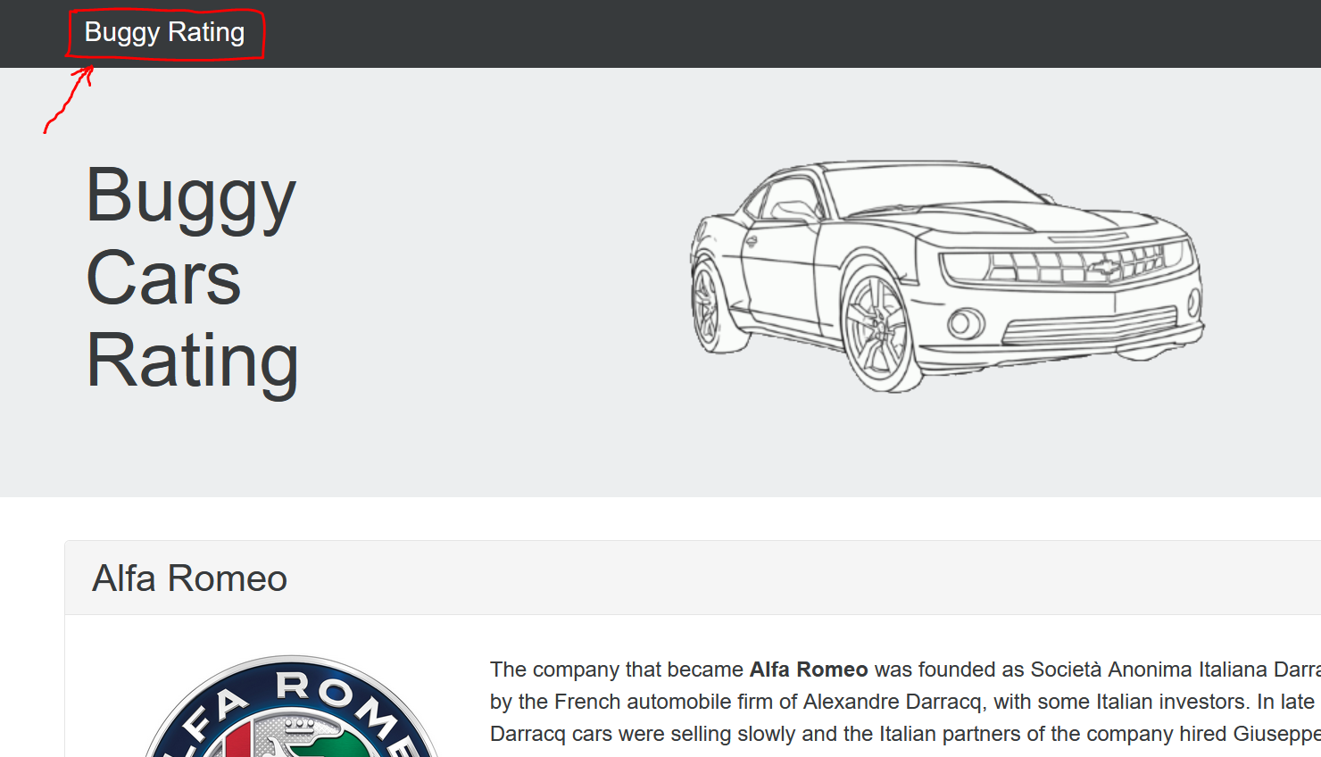

1. Subject: Sort by Rank is not working on 'Overall Rating' page

Description: On 'Overall Rating' page, the sorting of the list with 'Rank' column is not in the order.

Browser: Chrome, Firefox

Steps to Reproduce:

1. Open the application URL '<https://buggy.justtestit.org/>'
2. Click on the 'Overall Rating' card
3. Click on the 'Rank' column in the header row of the table to sort it

Expected Result: List should be sorted by Rank in the numeric order

Actual Result: List is not ordered by Rank

Screenshot Reference:

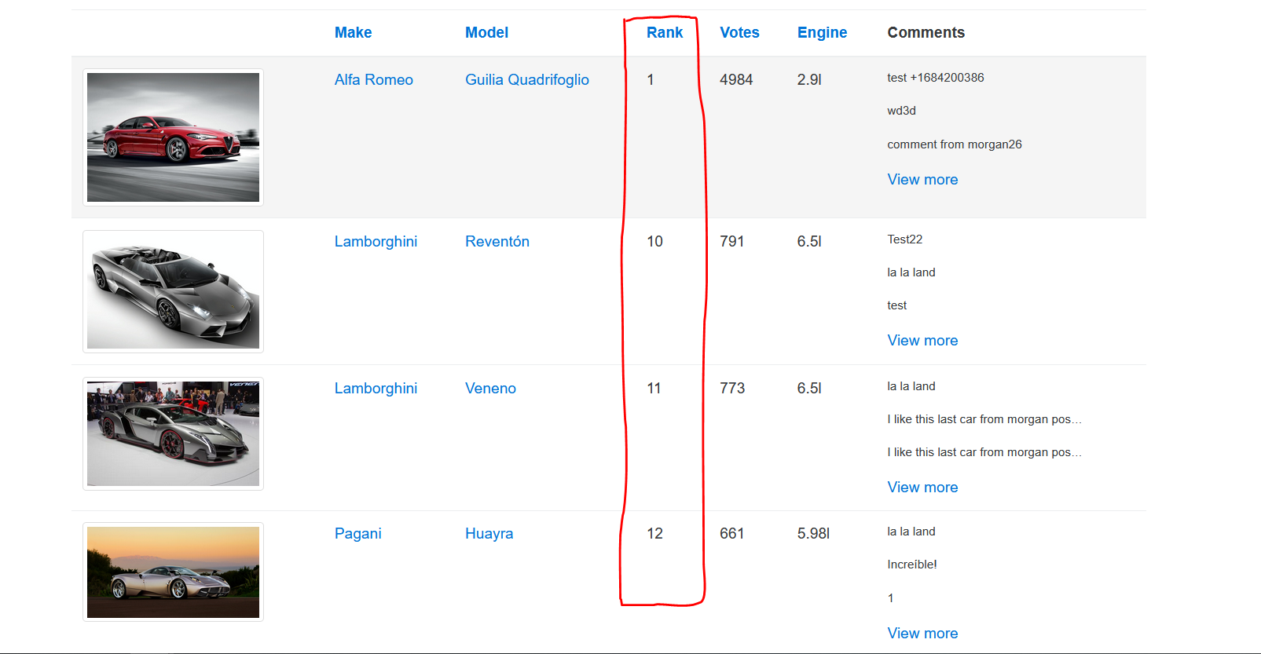

1. Subject: Image is broken for car model 'Lancia Ypsilon'

Description: On 'Overall Rating' page, the image is broken for the car model 'Lancia Ypsilon'

Browser: Chrome, Firefox

Steps to Reproduce:

1. Open the application URL '<https://buggy.justtestit.org/>'
2. Click on the 'Overall Rating' card
3. Navigate to page-4 using pagination at the bottom right corner
4. Locate the make 'Lancia' and look for model 'Ypsilon'

Expected Result: Image should be displayed for the car model 'Lancia Ypsilon'

Actual Result: Image is not displayed/broken for car model 'Lancia Ypsilon'

Screenshot Reference:

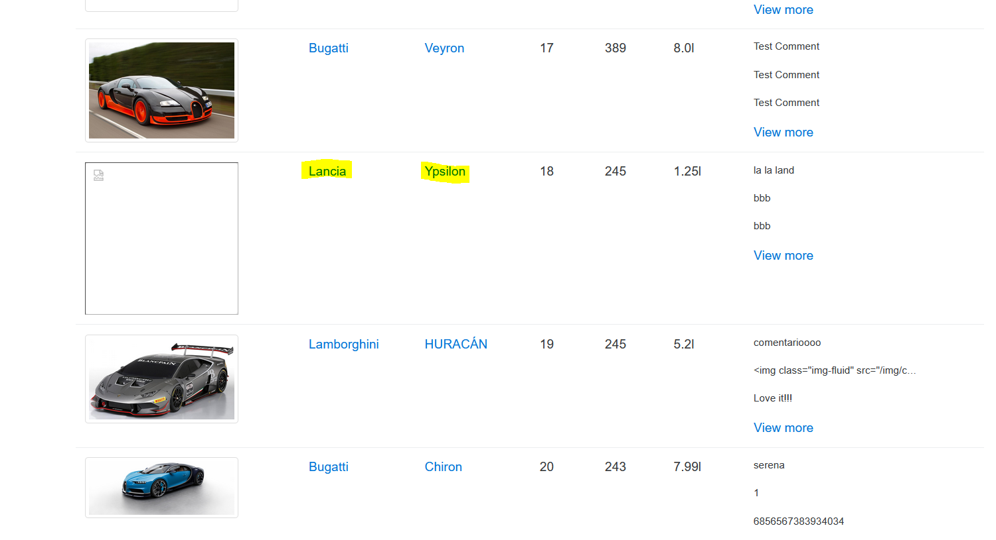

1. Subject: User is able to navigate beyond the page limit from pagination

Description: When user clicks on next [»] icon after reaching to last page, the user is able to click on it endlessly

Browser: Chrome, Firefox

Steps to Reproduce:

1. Open the application URL '<https://buggy.justtestit.org/>'
2. Click on the 'Overall Rating' card
3. In the pagination at the bottom right corner, navigate to last page
4. Keep clicking on the next [»] icon

Expected Result: After page limit is reach, the next [»] icon should be disabled by not allowing the user to navigate further

Actual Result: User is able to navigate to the pages beyond page limit that do not exit

Screenshot Reference:

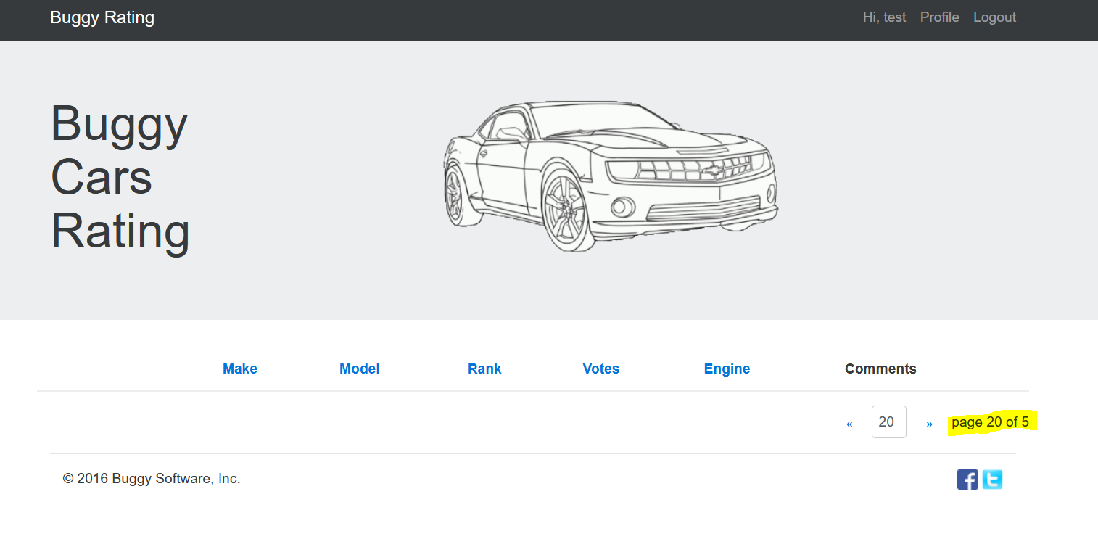

1. Subject: 'Popular Model' page is not loading on Firefox browser

Description: 'Popular Model' page is not loading on Firefox browser where as it is loading successfully on Chrome browser

Browser: Firefox

Steps to Reproduce:

1. Open the application URL '<https://buggy.justtestit.org/>'
2. Click on the 'Popular Model' card

Expected Result: 'Popular Model' page should be loaded successfully

Actual Result: 'Popular Model' page is not loading

Screenshot Reference:

